**Assignment - 2**

1. **Create ASP.NET Webpage that will take feedback details from user and Display it as testimonial. Feedback : Name, email and feedback desc.**

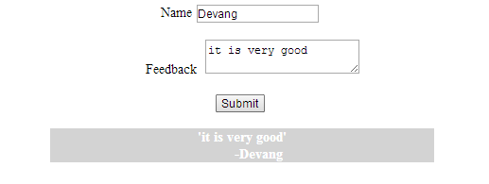

Design:

<form id="form1" runat="server">

<div>

<center>

<asp:Label ID="Label1" runat="server" Text="Name"></asp:Label>

<asp:TextBox ID="TextBox1" runat="server"></asp:TextBox>

<br /><br />

&nbsp;&nbsp;&nbsp;&nbsp;&nbsp;&nbsp;

<asp:Label ID="Label3" runat="server" Text="Feedback"></asp:Label>

&nbsp;<asp:TextBox ID="TextBox3" runat="server" TextMode="MultiLine"></asp:TextBox>

<br /><br />

<asp:Button ID="Button1" runat="server" Text="Submit" onclick="Button1_Click" />

<br /><br />

<div id="tes" style="width:30%;background-color:lightGray;color:white;font-weight:bold" runat="server">

</div>

</center>

</div>

</form>

Code:

protected void Button1_Click(object sender, EventArgs e)

{

string fed = "'" + TextBox3.Text +"'";

fed += "<br>&nbsp;&nbsp;&nbsp;&nbsp;&nbsp;&nbsp;&nbsp;&nbsp; -" + TextBox1.Text;

tes.InnerHtml = fed;

}

1. **Create ASP.NET Webpage that will upload any file to webserver.**

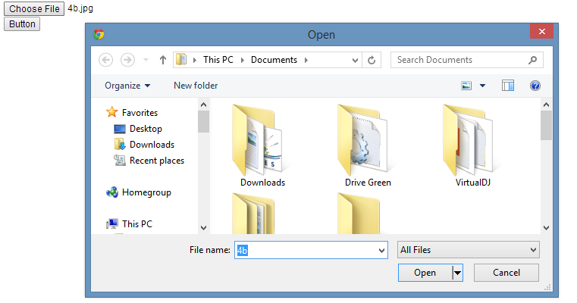

Design:

<form id="form1" runat="server"><div>

<asp:Label ID="Label1" runat="server" Text="Label"></asp:Label>

<br />

<asp:fileupload ID="Fileupload1" runat="server"></asp:fileupload>

<br />

<asp:Button ID="Button1" runat="server" Text="Button" onclick="Button1_Click"

PostBackUrl="~/Default.aspx" />

<p id="par" runat="server" ></p>

</div>

</form>

Code:

protected void Page_Load(object sender, EventArgs e)

{

}

protected void Button1_Click(object sender, EventArgs e)

{

if (Fileupload1.HasFile)

{

try

{

string filename = Path.GetFileName(Fileupload1.FileName);

Fileupload1.SaveAs(Server.MapPath("~/") + filename );

Label1.Text = "Upload status: File uploaded!";

}

catch (Exception ex)

{

Label1.Text = "Upload status: The file could not be uploaded. The following error occured: " + ex.Message;

}

}

1. **Create ASP.NET webpage that will display Sleeve Items in a listbox control. On the selection of display image and cost of item.**
2. **In above ASP.NET Webpage allow user to add quantity in textbox control (i.e Read only) on click of + & - button controls quantity should be increment & decrement then calculate payment.**

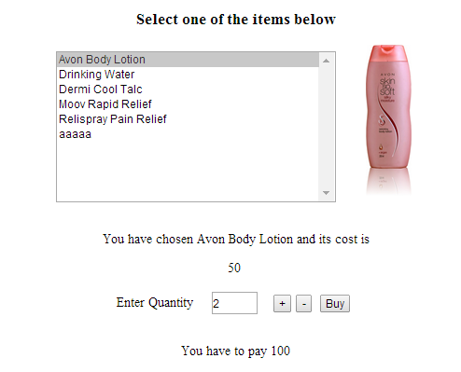

Design:

<html xmlns="http://www.w3.org/1999/xhtml">

<head runat="server">

<title>Untitled Page</title>

<style type="text/css">

#msg

{

width: 533px;

}

</style>

</head>

<body >

<form id="form1" runat="server">

<div>

<center>

<h3>Select one of the items below</h3>

<asp:ListBox ID="ListBox1" runat="server" AutoPostBack="True" Height="180px"

onselectedindexchanged="ListBox1_SelectedIndexChanged" Width="333px">

<asp:ListItem>Avon Body Lotion</asp:ListItem>

<asp:ListItem>Drinking Water</asp:ListItem>

<asp:ListItem>Dermi Cool Talc</asp:ListItem>

<asp:ListItem>Moov Rapid Relief</asp:ListItem>

<asp:ListItem>Relispray Pain Relief</asp:ListItem>

<asp:ListItem>aaaaa</asp:ListItem>

</asp:ListBox>

&nbsp;&nbsp;&nbsp;&nbsp;&nbsp;&nbsp;

<asp:Image ID="Image1" runat="server" Height="180px" />

<br />

<br />

<p id="msg" runat="server"></p> <asp:Label ID="Label1" runat="server" Text="Label"></asp:Label>

<br /><br />

Enter Quantity &nbsp;&nbsp;&nbsp;

<asp:TextBox ID="TextBox1" runat="server" Width="52px" Height="22px"

ReadOnly="True">0</asp:TextBox>

&nbsp;&nbsp;&nbsp;<asp:Button ID="Button2" runat="server" Text="+"

onclick="Button2_Click" />

<asp:Button ID="Button3" runat="server" Text="-" onclick="Button3_Click"

style="width: 18px" />

&nbsp;<asp:Button

ID="Button1" runat="server" Text="Buy" onclick="Button1_Click" />

<br /><br />

<p id="paymsg" runat="server"></p>

</center>

</div>

</form>

</body>

</html>

Code:

int cost = 0;

protected void Page_Load(object sender, EventArgs e)

{

}

protected void ListBox1_SelectedIndexChanged(object sender, EventArgs e)

{

int i = ListBox1.SelectedIndex;

//Response.Write(i);

int cost;

switch (i)

{

case 0:

Image1.ImageUrl = "~/Sleev1.jpg";

cost = 50;

break;

case 1:

Image1.ImageUrl = "~/Sleev2.jpg";

cost = 30;

break;

case 2: Image1.ImageUrl = "~/Sleev3.jpg";

cost = 60;

break;

case 3: Image1.ImageUrl = "~/Sleev4.jpg";

cost = 70;

break;

case 4: Image1.ImageUrl = "~/Sleev5.jpg";

cost = 45;

break;

}

msg.InnerHtml = "You have chosen " + ListBox1.SelectedValue + " and its cost is " + cost;

Label1.Text = cost.ToString();

}

protected void Button1_Click(object sender, EventArgs e)

{

cost = int.Parse(Label1.Text) * int.Parse(TextBox1.Text);

Label2.Text = "You have to pay " + cost;

}

protected void Button2_Click(object sender, EventArgs e)

{

int i = int.Parse(TextBox1.Text);

++i;

TextBox1.Text = i.ToString();

}

protected void Button3_Click(object sender, EventArgs e)

{

int i = int.Parse(TextBox1.Text);

--i;

TextBox1.Text = i.ToString();

}

1. **write a asp.net webpage that will make student exam details from exam form and generate fee reciept. exam details : name , exam type year ,sem subjects fees.**

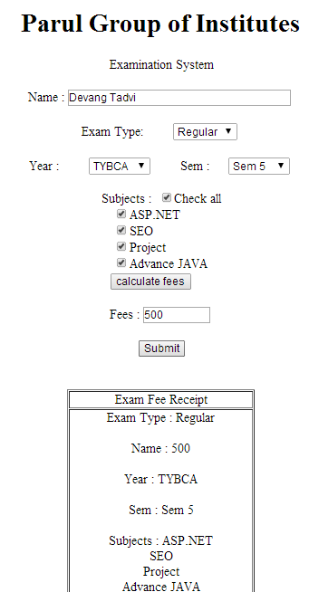

* Notes: AutoPostBack=True - DropLists :Exam Type,Year,Sem,CheckAll CheckBox